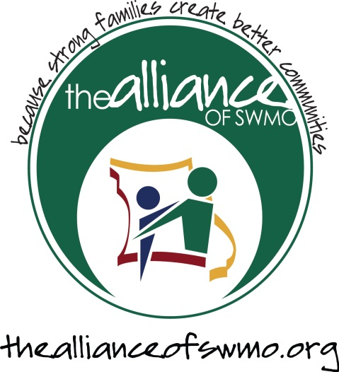

Youth Mental Health First Aid training available

Eight-hour Youth Mental Health First Aid classes are available in your community or school through Missouri’s Prevention Resource Network.
Youth Mental Health First Aid is a public education program which introduces participants to the unique risk factors and warning signs of mental health problems in adolescents, builds understanding of the importance of early intervention, and – most importantly – teaches individuals how to help a youth in crisis or experiencing a mental health or substance use challenge. Mental Health First Aid uses role-playing and simulations to demonstrate how to assess a mental health crisis; select interventions and provide initial help; and connect young people to professional, peer, social, and self-help care.
The Alliance of SWMO has committed to making the Youth Mental Health First Aid training available to all youth-serving agencies, and general public, in all of the counties that we service.
To schedule training for your organization, please contact:
Robin Standridge (417)358-3270

